# CS 255 System Design Document Template

## UML Diagrams

### UML Use Case Diagram

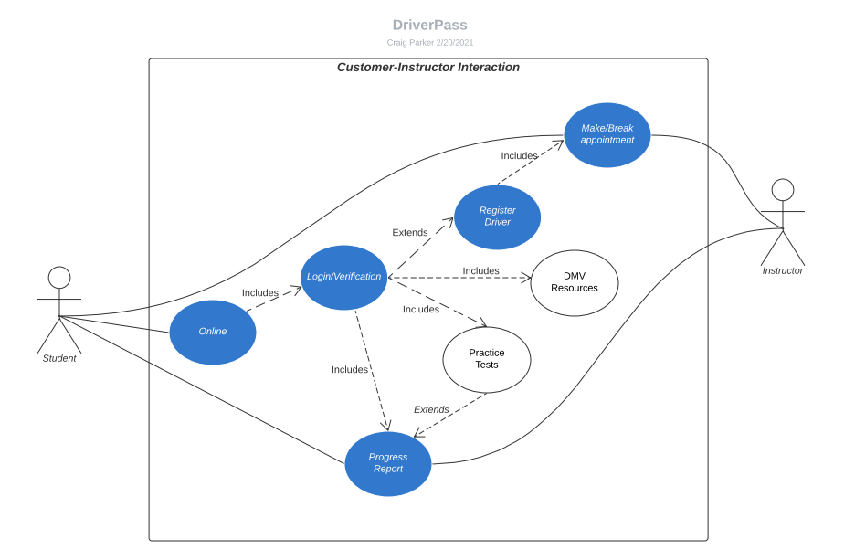

### UML Activity Diagrams

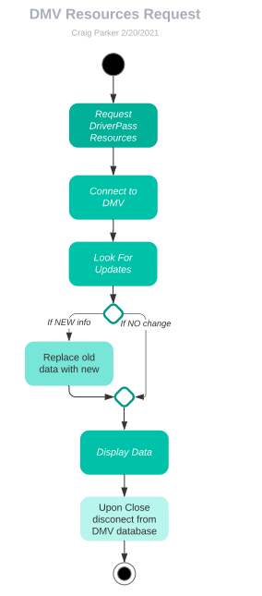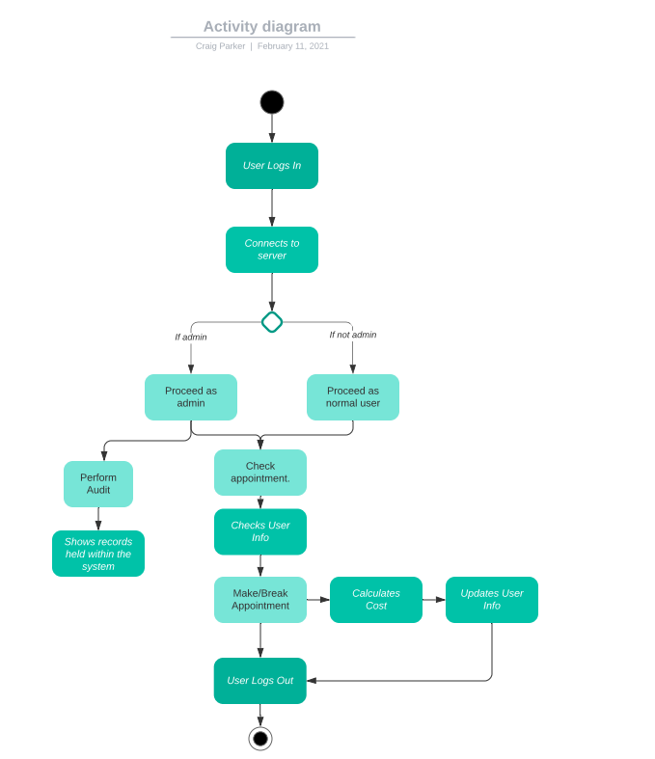

### UML Sequence Diagram

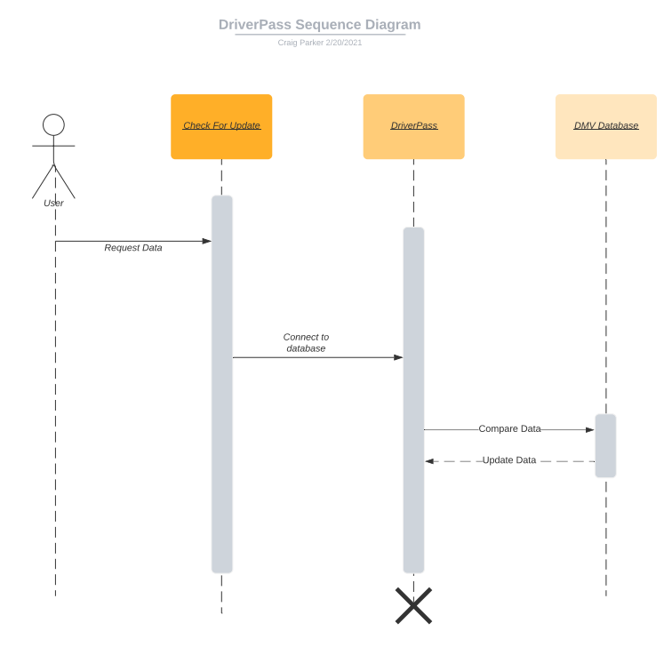

### UML Class Diagram

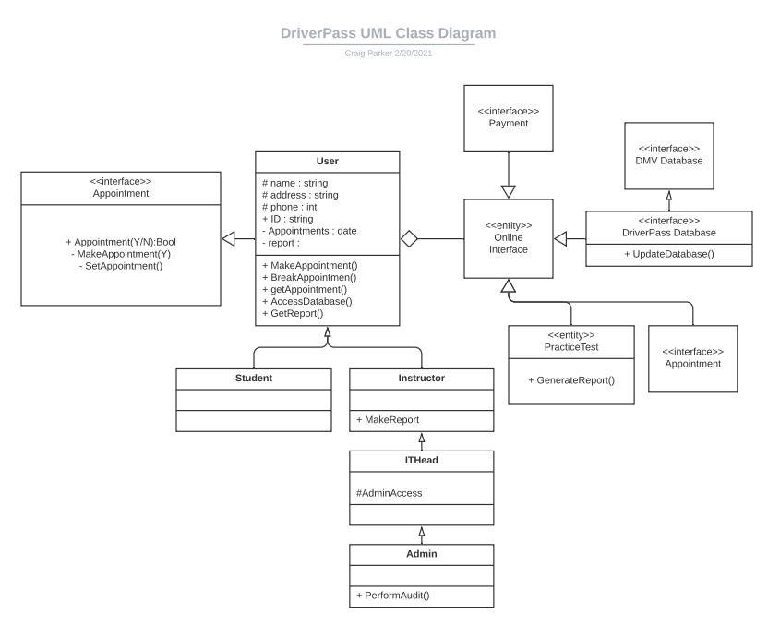

## Technical Requirements

* The system will need a secure connection to the Internet.
* The ability to access/store data within a server database.
* The ability to run as a plug-in on web browsers.
* The ability to do an audit.
* User verification (log-in/pass.)
* A server to host the application.

Most of these Prerequisites are attainable through the infrastructure provided by the internet. Third-party servers can be used to host data and security can also be outsourced to third party companies specializing in that specific field.